**DATA TYPES, OPERATORS AND**

**EXPRESSIONS IN C++**

**LAB # 2**



**Spring 2019**

**CSE102L Computer Programming Lab**

Submitted by: **SHAH RAZA**

Registration No. : **18PWCSE1658**

Class Section: **B**

“On my honor, as student of University of Engineering and Technology, I have neither given nor received unauthorized assistance on this academic work.”

Student Signature: ______________

Submitted to:

**Engr. Madiha Sher**

February 23, 2019

Department of Computer Systems Engineering

University of Engineering and Technology, Peshawar

**Lab Objective(s)**

* To be familiar with different data types, Operators and Expressions in C++.

**TASK #1:**

**Title:**

Write a program that takes the temperature in Fahrenheit and convert it to Celsius And Kelvin:

K = C + 273

C = (F – 32) / 1.8

### **Problem Analysis:**

The problem is to convert the temperature in Fahrenheit to Celsius and Kelvin having its inputs parameters identified as: F (float type). The output of the program is to display the temperature in Celsius and Kelvin; hence the output parameters are identified as C (float type) and K (float type). During the processing or calculation phase, we don’t need any extra parameters (variables) for this problem.

The temperature in Celsius is equal to temperature in Fahrenheit minus 32 divided by 1.8 and temperature in kelvin is equal to temperature in Celsius plus 273, hence the mathematical formulas to calculate C and K are:

Celsius = (Fahrenheit - 32)/1.8. (C = (F-32)/1.8)

Kelvin = Celsius + 273. (K = C + 273)

|  |  |  |  |
| --- | --- | --- | --- |
| Input variables | Processing variables/calculations | Output variables | Necessary header files/functions/macros |
| F (float) | C = (F-32)/1.8  K = C + 273 | C (float)  K (float) | iostream.h |

**Code:**

#include <iostream> /* library for writing

the output to console window*/

using namespace std;

int main()

{

//variables declaration

float F,C,K;

cout << "Enter temperature in Fahrenheit" << endl;

cin>>F; //Temperature in Fahrenheit

/*calculation using

mathematical formula*/

C=(F-32)/1.8;

K=C+273;

// Display the temperature in Celsius

cout << "Temperature in Celsius= " << C << endl;

// Display the temperature in Kelvin

cout << "Temperature in Kelvin= " << K << endl;

return 0;

}

### **Output (Compilation, Debugging & Testing):**

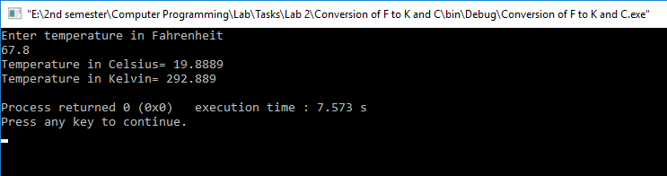

**TASK # 2:**

**Title:**

Write the C++ code that takes the integer a, b, c, d and e from the user and display the output according to the following equation.

a3 + b2 – d / b

a ( b + c ( e + a ) / b )- 10

### **Problem Analysis:**

The problem is to solve the given equation having its inputs parameters identified as: a (int type), b (int type), c (int type), d (int type) and e (int type). The output of the program is to display the result of the given equation; hence the output parameter is identified as res (float type). During the processing or calculation phase, we don’t need any extra parameters (variables) for this problem.

|  |  |  |  |
| --- | --- | --- | --- |
| Input variables | Processing variables/calculations | Output variables | Necessary header files/functions/macros |
| a (int)  b (int)  c (int)  d (int)  e (int) | res = ((a*a*a+b*b)-d/b)/(a*(b+c*(e+a)/b)-10) | res (float) | iostream.h |

**Code:**

#include <iostream> /* library for writing

the output to console window*/

using namespace std;

int main()

{

//Variable declaration

int a,b,c,d,e;

float res;

/*Prompt the user to enter

the values of a,b,c,d and e */

cout << "Enter the integer a"<<endl;

cin >> a ;

cout << "Enter the integer b"<<endl;

cin >> b;

cout << "Enter the integer c"<<endl;

cin >> c;

cout << "Enter the integer d"<<endl;

cin >> d;

cout << "Enter the integer e"<<endl;

cin >> e;

//Calculation

res= ((a*a*a+b*b)-d/b)/(a*(b+c*(e+a)/b)-10);

//Display the Result of the equation

cout << "The result is:" << res;

return 0;

}

**Output (Compilation, Debugging & Testing):**

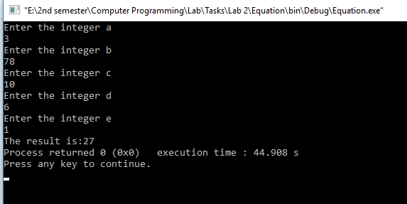

**TASK # 3:**

**Title:**

Write a program to declare two integer and one float variables then initialize them to 10, 15, and 12.6. Also print the variable values on the screen.

### **Problem Analysis:**

The problem is to show two integer and one float value on console having its inputs parameters identified as: A (int type), B (int type) and C (float type). The output of the program is to display these variable values; hence the output parameters are identified as A (int type), B (int type) and C (float type). During the processing or calculation phase, we don’t need any extra parameters (variables) for this problem.

|  |  |  |  |
| --- | --- | --- | --- |
| Input variables | Processing variables/calculations | Output variables | Necessary header files/functions/macros |
| A (int)  B (int)  C (float) | A = 10  B = 15  C = 12.6 | A (int)  B (int)  C (float) | iostream.h |

**Code:**

#include <iostream> /* library for writing

the output to console window*/

using namespace std;

int main()

{

/*Variable declaration

and assignment*/

//integers

int A=10,B=15;

//floating point

float C=12.6;

//Display integers

cout<<"Integer variables: "<<endl;

cout<<"A= "<< A <<endl;

cout<<"B= "<< B <<endl<<endl;

//Display floating point

cout<<"Float variable: "<<endl;

cout<<"C= "<< C <<endl;

return 0;

}

**Output (Compilation, Debugging & Testing):**

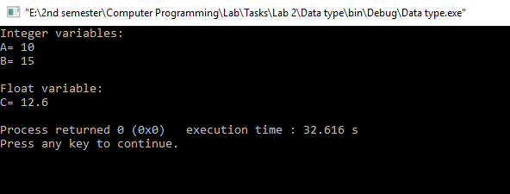

**TASK # 4:**

**Title:**

Write a C++ program to prompt the user to input 3 integer values and print these values in forward and reversed order.

### **Problem Analysis:**

The problem is to show three integer variables in forward and reverse order having its inputs parameters identified as: A (int type), B (int type) and C (int type). The output of the program is to display these variable values in forward and reverse order. During the processing or calculation phase, we don’t need any extra parameters (variables) for this problem.

**Code:**

#include <iostream>/* library for writing

the output to console window*/

using namespace std;

int main()

{

//Variable declaration

int A,B,C;

//Prompt the user to enter the values of A, B and C

cout << "Enter the value of A " << endl;

cin>>A;

cout << "Enter the value of B " << endl;

cin>>B;

cout << "Enter the value of C " << endl;

cin>>C;

//Forward order

cout << "Forward Order: " << A <<", "<< B <<", "<< C << endl;

//Reverse order

cout << "Reverse Order: " << C <<", "<< B <<", "<< A << endl;

return 0;

}

**Output (Compilation, Debugging & Testing):**

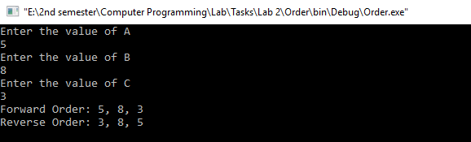

**TASK # 5:**

**Title:**

Write a program to swap two variables values with and without using third variables.

**Code:**

#include <iostream>/* library for writing

the output to console window*/

using namespace std;

int main()

{

//with third variable

cout << "Using Third Variable " << endl<<endl;

//Variable declaration

int A,B,C;

//Prompt the user to enter the values of A and B

cout << "Enter the value of A: ";

cin>>A;

cout << "Enter the value of B: ";

cin>>B;

cout<<endl<<endl;

//Before Swapping

cout << "Before Swapping: " << endl;

cout << "A= " << A << endl;

cout << "B= " << B << endl<<endl;

//Swapping Process

C=A;

A=B;

B=C;

//After Swapping

cout << "After Swapping: " << endl;

cout << "A= " << A << endl;

cout << "B= " << C << endl<<endl;

//without third variable

cout << "Without Using Third Variable " << endl<<endl;

//Enter the values to A and B again

cout << "Enter the value of A: ";

cin>>A;

cout << "Enter the value of B: ";

cin>>B;

cout<<endl<<endl;

//Before Swapping

cout << "Before Swapping: " << endl;

cout << "A= " << A << endl;

cout << "B= " << B << endl<<endl;

//Swapping Process

A=A+B;

B=A-B;

A=A-B;

//After Swapping

cout << "After Swapping: " << endl;

cout << "A= " << A << endl;

cout << "B= " << B << endl;

return 0;

}

**Output (Compilation, Debugging & Testing):**

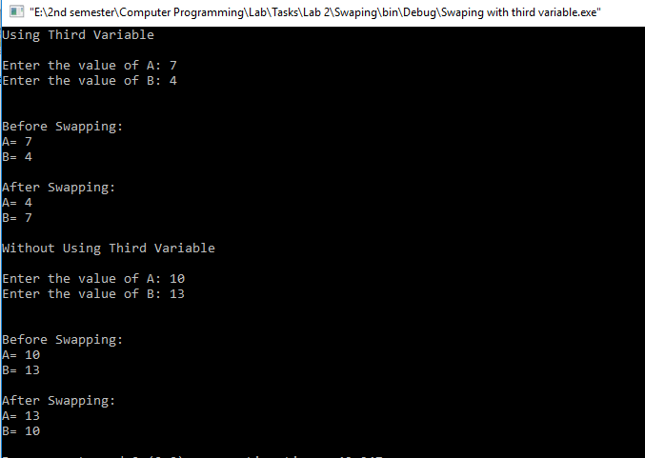

**TASK # 6:**

**Title:**

Write a program to print the size of char, float, double and long double data types in C.

### **Problem Analysis:**

The problem is to Print the size of char, float, double and long double. This can be done using the keyword sizeof. During the processing or calculation phase, we don’t need any extra parameters (variables) for this problem.

|  |  |  |  |
| --- | --- | --- | --- |
| Input variables | Processing variables/calculations | Output variables | Necessary header files/functions/macros |
|  | Sizeof(char)  Sizeof(float)  Sizeof(double)  Sizeof(long double) | Sizeof(char)(int)  Sizeof(float)(int)  Sizeof(double)(int)  Sizeof(long double)(int) | iostream.h |

### **Algorithm:**

1. Start
2. Calculate the size of char as: sizeof(char)
3. Calculate the size of float as: sizeof(floar)
4. Calculate the size of double as: sizeof(double)
5. Calculate the size of long double as: sizeof(long double)
6. Display sizeof(char)
7. Display sizeof(float)
8. Display sizeof(double)
9. Display sizeof(long double)
10. Stop

Start

Calculate the size of char using sizeof

Calculate the size of float using sizeof

Calculate the size of double using sizeof

Calculate the size of long double using sizeof

Display sizeof(char)

Display sizeof(float)

Display sizeof(double)

Display sizeof(long double)

Stop

**Code:**

#include <iostream> /* library for writing

the output to console window*/

using namespace std;

int main()

{

//Data types with their sizes

cout << "Sizes of Data Types " << endl<<endl;

//char

cout << "Size of char: " << sizeof(char) <<" Byte(s)"<< endl;

//float

cout << "Size of float: " << sizeof(float) <<" Byte(s)"<< endl;

//double

cout << "Size of double: " << sizeof(double) <<" Byte(s)"<< endl;

//long double

cout << "Size of long double : " << sizeof(long double) <<" Byte(s)"<< endl;

return 0;

}

**Output (Compilation, Debugging & Testing):**

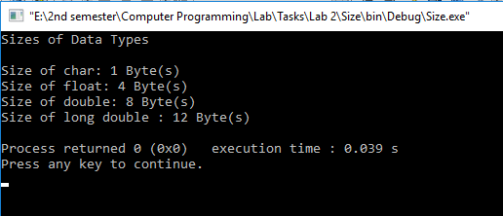

**TASK # 7:**

**Title:**

Write a program that checks the bit # 4 in the integer entered by user. Print 0 on console if the 4th bit was 1. Print 1 if the bit was 0.

### **Problem Analysis:**

The problem is to print 0 if the 4th bit of integer entered by the user is 1 and print 1 if its 4th bit is 0 having its inputs parameters identified as: num (integer type). The output of the program is to display 0 if the 4th bit of integer entered by the user is 1 and print 1 if its 4th bit is 0; hence the output parameter is identified as a (bool type). During the processing or calculation phase, we don’t need any extra parameters (variables) for this problem.

To solve this problem, we use OR and NOT bitwise operators, hence the mathematical formula to solve this problem is:

a = number | 4294967287. (a = num | 4294967287)

a = ~a

|  |  |  |  |
| --- | --- | --- | --- |
| Input variables | Processing variables/calculations | Output variables | Necessary header files/functions/macros |
| num (int) | a=num|4294967287  a = ~a | a (bool) | iostream.h |

### **Algorithm:**

1. Start
2. Variable declaration: num (int); a (bool);
3. Ask for the value of num from the user
4. Calculations: a = num | 4294967287;a= ~a;
5. Display the value of a
6. Stop

**Flowchart:**

Start

Stop

Variable declaration:

num (int), a (bool)

Read num

a =num|4294967287

a = ~ a

Display a using cout

**Code:**

#include <iostream> /* library for writing

the output to console window*/

using namespace std;

int main()

{

//Variable declaration

int num;//integer

bool a;//boolean

//Prompt the user to enter num

cout << "Enter the number: ";

cin>>num;

//white spacing

cout<<endl;

//Operations

a=num|4294967287;

a=~a;

//NOT of 4th bit

cout<<"NOT of 4th bit= " << a ;

return 0;

}

**Output (Compilation, Debugging & Testing):**

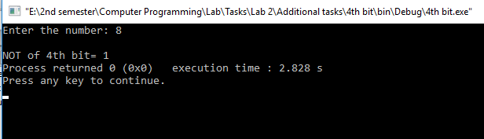

**TASK # 8:**

**Title:**

Write a program that flips the bit # 3 in the integer entered by user.

### **Problem Analysis:**

The problem is to flip the third bit of an integer entered by the user having its inputs parameters identified as: num (integer type). The output of the program is to display the number after the 3rd bit of the original number is flipped; hence the output parameter is identified as a (int type). During the processing or calculation phase, we don’t need any extra parameters (variables) for this problem.

To solve this problem, we use XOR bitwise operator, hence the mathematical formula to solve this problem is:

a = number ^ 4. (a = num ^ 4)

|  |  |  |  |
| --- | --- | --- | --- |
| Input variables | Processing variables/calculations | Output variables | Necessary header files/functions/macros |
| num (int) | a = num ^ 4 | a (int) | iostream.h |

### **Algorithm:**

1. Start
2. Variable declaration: num (int); a (int);
3. Ask for the value of num from the user
4. Calculations: a = num ^ 4;
5. Display the value of a
6. Stop

**Flowchart:**

**Code:**

Start

Stop

Variable declaration:

num (int), a (int)

Read num

a = num ^ 4

Display a using cout

#include <iostream> /* library for writing

the output to console window*/

using namespace std;

int main()

{

//variable declaration

int num,a;

//Read num

cout << "Enter a number: " ;

cin>>num;

//white spacing

cout<<endl;

//Flipping process

a=num^4;

//Display a

cout<<"After the 3rd bit is flipped, num= "<< a <<endl;

return 0;

}

**Output (Compilation, Debugging & Testing):**

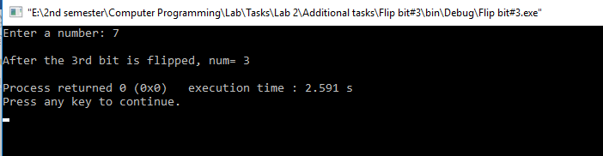

**TASK # 9:**

**Title:**

Write a C++ program to swap two Integers using Bitwise Operators.

### **Problem Analysis:**

The problem is to swap the values of two integer variables using bitwise operators having its inputs parameters identified as: A (integer type), B (integer type). The output of the program is to display the variables after their values are swapped; hence the output parameter is identified as A(int type) and B(int type). During the processing or calculation phase, we need a third variable C(int type) for this problem.

To solve this problem, we use XOR bitwise operator, hence the mathematical formula to solve this problem is:

C = A ^ B

A = C ^ A

B = C ^ B

|  |  |  |  |
| --- | --- | --- | --- |
| Input variables | Processing variables/calculations | Output variables | Necessary header files/functions/macros |
| A (int)  B (int) | C = A ^ B  A = C ^ A  B = C ^ B | A (int)  B (int) | iostream.h |

### **Algorithm:**

1. Start
2. Variable declaration: A (int); B (int); C(int);
3. Ask for the value of A and B from the user
4. Calculations: C = A ^ B; A = C ^ A; B = C ^ B;
5. Display the value of A
6. Display the value of B
7. Stop

**Flowchart:**

**Code:**

Start

Stop

Variable declaration:

A (int), B (int), C(int)

Read A

B = C ^ B

Display A using cout

Read B

C = A ^ B

A = C ^ A

Display B using cout

#include <iostream> /* library for writing

the output to console window*/

using namespace std;

int main()

{

//Variable declaration

int A,B,C;

//Prompt the user to enter values of A and B

cout << "Enter the value of A" << endl;

cin>>A;

cout << "Enter the value of B" << endl;

cin>>B;

//white spacing

cout<<endl;

//Values before swapping

cout << "Before Swapping:" << endl;

cout << "value of A= " << A << endl;

cout << "value of B= " << B << endl<<endl;

//Swapping values using bitwise XOR operator

C=A^B;

A=C^A;

B=C^B;

//Values after swapping

cout << "After Swapping:" << endl;

cout << "value of A= " << A << endl;

cout << "value of B= " << B << endl;

return 0;

}

**Output (Compilation, Debugging & Testing):**

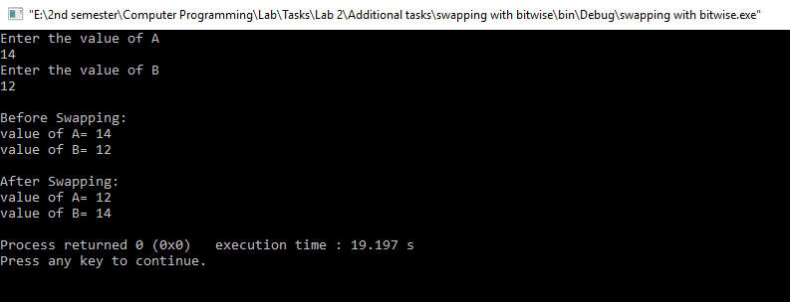

**TASK # 10:**

**Title:**

Write a C++ program that takes two integers as input and prints the output of following equation:

C = A AND B

D = A OR B

E = NOT OF A

F = A XOR B

### **Problem Analysis:**

The problem is to take two integers from user and solve the given equations having its inputs parameters identified as: A (integer type), B (integer type). The output of the program is to display the results of the given equations; hence the output parameter is identified as C (int type), D (int type), E (int type) and F (int type). During the processing or calculation phase, we don’t need any extra variable for this problem.

To solve this problem, we use XOR , AND, OR and NOT bitwise operators, hence the mathematical formulas to solve this problem are:

C = A AND B

D = A OR B

E = NOT OF A

F = A XOR B

|  |  |  |  |
| --- | --- | --- | --- |
| Input variables | Processing variables/calculations | Output variables | Necessary header files/functions/macros |
| A (int)  B (int) | C = A & B  D = A | B  E = ~A  F = A ^ B | C (int)  D (int)  E (int)  F (int) | iostream.h |

### **Algorithm:**

1. Start
2. Variable declaration: A (int); B (int); C (int);D (int);E (int);F (int);
3. Read A
4. Read B
5. C = A & B;
6. D = A | B;
7. E = ~A;
8. F = A ^ B;
9. Display the value of C
10. Display the value of D
11. Display the value of E
12. Display the value of F
13. Stop

**Flowchart:**

**Code:**

#include <iostream> /* library for writing

the output to console window*/

using namespace std;

int main()

{

//variable declaration

int A,B,C,D,E,F;

//Prompt the user to enter the values of A and B

cout << "Enter the value of A: ";

cin>>A;

cout << "Enter the value of B: ";

cin>>B;

//Calculations

C=A&B;D=A|B;E=~A;F=A^B;

//Results of the calculations

cout << "Value of C= " << C << endl;

cout << "Value of D= " << D << endl;

cout << "Value of E= " << E << endl;

cout << "Value of F= " << F << endl;

return 0;

}

Start

Stop

Variable declaration:

A (int), B (int), C(int),D(int),E(int),F(int)

Read A

Display C using cout

Read B

C = A & B;D = A | B

E = ~ A; F = A ^ B

Display D using cout

Display E using cout

Display F using cout

**Output (Compilation, Debugging & Testing):**

